**Software Engineering**

Q1. Give your definition for ‘Software Engineering.’

Q2. Consider the following quote.

“comparing bridge building to software development, bridges are normally built on-time, on- budget, and do not fall down. On the other hand, software never comes in on-time or on-budget. In addition, it always breaks down.” - Alfred Spector

What are the three key differences between building a bridge and building software?

Q3. The Standish Group research (2012) states

…with 39% of all projects succeeding (delivered on time, on budget, with required features and functions); 43% were challenged (late, over budget, and/or with less than the required features and functions); and 18% failed (cancelled prior to completion or delivered and never used).

Give three main reasons for IT project failures.

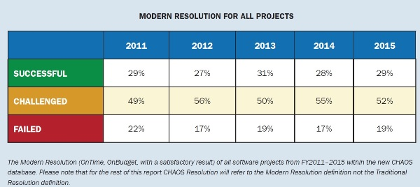

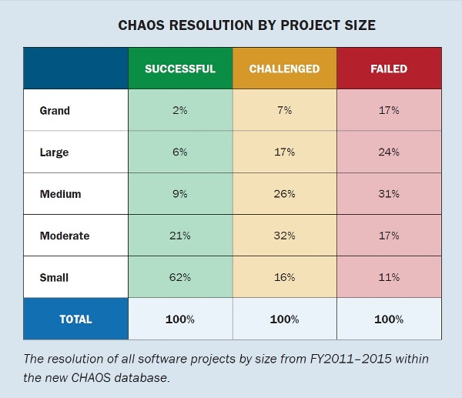

http://www.networkcomputing.com/data-centers/5-reasons-it-projects-fail/1467876786

Q4. According to the Standish Group Big Bang Boom (2014) article:

It has become the general IT industry practice to reduce the cost of quality. Many well-known large IT providers make their customers become their quality control department. Many users and customers have grown to accept poor quality software applications as a cost of doing business.

Give four main characteristics of quality software?

Q5. What are the main stages in the traditional software development process? Briefly explain the activities involved in each stage.

Q6. Explain the traditional waterfall model. Contrast it with SDLC, Iterative and Incremental process models.

Q7. According to Standish 2013 manifesto,

The agile process is now perceived as the universal remedy for software development project failure.

How Agile approaches are different form traditional process models such as SDLC? Give at least three differences?

Q8. Discuss two key drawbacks of Agile approach.

Q9. Explain the following terms in the context of XP.

Text-driven Development

Shared Responsibility

Paired Programming

Test-driven Development

Q10. There are lots of SCRUM projects not performing well. Recently, Martin Fowler noted [‘Flaccid Scrum’ <http://martinfowler.com/bliki/FlaccidScrum.html> ] “Scrum is a process that's centered on project management techniques and deliberately omits any technical practices, in contrast to (for example) Extreme Programming”. Shortly describe the key practices involved in SCRUM and compare it with XP approach.

Q11. Discuss 4 main activities in Requirement Engineering

* 1. Explain the role of prototyping in Requirement Engineering.

Q12. Give three main purposes of Software Requirement Specification (SRS)? Explain at least 5 characteristics (out of 8 characteristics given in IEEE830)of a good SRS.

Q13. Describe the main characteristics of Open Source Development process. Compare and contrast Open Source with Agile approach.

Q14. Explain the following concepts and their pros and cons in the context of XP:

Test Driven Programming; Paired Programming; Collective Ownership; Simple Design.

Q15. Why prioritizing requirements is important? Which stakeholder will be responsible for this activity?

Q16. What is acceptance testing? Who create the test cases? Who tests them?

* 1. Give 3 suitable acceptance test cases for ATM withdraw functionality.

|  |  |  |  |  |
| --- | --- | --- | --- | --- |
| Input | | Expected Output | Output | Date |
| Balance = | Withdraw Amount= | Balance= |  |  |
|  |  |  |  |  |
|  |  |  |  |  |
|  |  |  |  |  |

Q17. What is 4+1 modal in Architecture?

Consider the following architectures;

Pipe &Filter, Client-Server, M_V_C, Layered, Three/Four-tier, Event-Driven,

Write short notes about each of the above architectures- include at least the following; brief description, example, advantages and disadvantages.

Identify the main architecture used in the following situations. Justify your answer.

1. A compiler reads a program, parse it and converts it into binary code
2. Two directory lists are opened on a desktop.
3. Claflin Moodle is used by many students
4. OS interface modules cannot access the hardware directly.
5. A kiosk at an airport is waiting for a user to touch the screen.
6. A student enrolls for a course on the Claflin web site.

Q18. Define Cohesion and Coupling.

Explain how they affect the efficiency of software design.

**CASE STUDIES**

[1]

Pembroke library introduced a number of kiosks in order to enable the members to use their card to check-out a material (books or DVDs). Every member is given only one card. Member cannot check-out a material if they are not in a good status. [The above narrative is not complete, clearly state any assumptions you make]

Draw a class diagram. Include important attributes, relationships and cardinalities.

Identify a composite relationship. Explain why it is not an aggregate?

Identify a Special- General Relationship.

Draw the sequence diagram for the usecase “borrow a book using kiosk”.

[2]

You have been asked by a charity to create a system that keeps track of all donations they have received for tax write off purposes. This system has to maintain the names and addresses of donors, the number of times they have donated in a year, the amount donated, and when it was donated. If the total donations do not exceed $2,000 and there have not been over 5 donations, the system will send a TAX write off receipt. Any amounts over the limit will not be included in the receipt if they have not had more than 5 donations. If they have over $2,000 and over 5 donations, they get SPECIAL TAX write off receipt. Weekly Reports are done which give the total donations to the charity for each week. And so on…..

You plan to suggest a web based solution.

[3]

A fast-food store wishes to reengineer their drive-through order processing in the following manner. When a customer arrives at the ordering area, he/she place their order using a microphone. The clerk at window-1 receives the order and inputs the details in the system. The order detail and cost will be displayed on the screens both at ordering area and at window-1. When the customer confirms the order the clerk at window-1 confirms the order on the system. After the customer makes the payment at window-1, the clerk processes the payment and the order details will be displayed on the screen at the kitchen and at window-2. A receipt will also be printed at window-2. When a particular order is ready, the kitchen staff notifies it on the system and the screen at window-2 will reflect that information. When the customer arrives at window-2, another worker will issue the order and receipt. He/she also notify the system that the order is completed. At the end of the day the manager will be able to view/print a report regarding the sale details and things need to be reordered.

Create an Activity Diagram for the whole order processing (use swim lanes and synchronization bars if necessary)

Draw a usecase Diagram and Descriptions (for the main requirement)

Draw Analysis Level Class Diagram: Include Entity Classes and Attributes

Identify Multiplicity Constraints